SESSION 3:
INTRODUCTION TO SDLC + V MODEL

- Draw the V-Model diagram on paper or using any digital tool, and clearly label each phase with both the developer and tester roles involved at each step.

- V-Model Diagram:
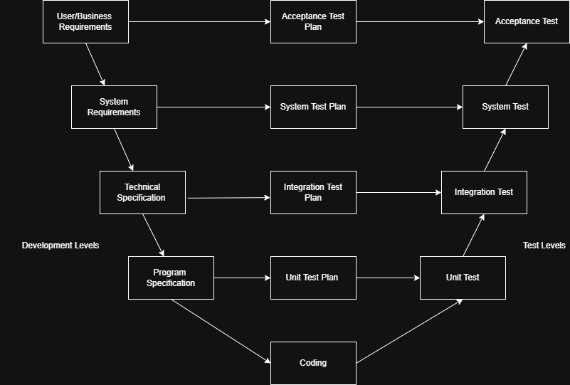
- Pick any app you use daily (like Zomato, Instagram, or Paytm) and write a short table mapping each SDLC phase (Requirement, Design, Coding, Testing, Deployment, Maintenance) to a real activity that would happen for that app.

- Zomato SDLC Phase Mapping:

- Requirement Gathering:
Product managers identify that corporate users want to schedule lunch orders at 9:00 AM to avoid peak lunchtime delivery delays. They define the business rules: “Users can schedule an order up to 48 hours in advance, but only from restaurants that agree to accept advance pre-orders”.

- Design:
UI/UX: Designers create prototype csreens for a “Deliver Now vs Schedule for Later” time-picker wheel at the checkout screen.

- Coding (Development):
Frontend: Mobile developers build the time-slot picker UI for iOS and Android. Backend: Software engineers write the algorithms to dynamically calculate food preparation times and assign delivery riders based on forcasted traffic conditions at that future hour.

- Testing (QA/QC):
Testers execute targeted test scenarios: What happens if a users schedules an order for 8:00pm, but the restaurant unexpectedly closes at 7:00om? What happens if the user travels to a different time zones after placing the scheduled order? They also run automated load tests to ensure 1000 of pre-scheduled Sunday dinner orders don’t crash the server when released at once.

- Deployment:
The DevOps team releases the feature quietly using a Feature Flag or a canary deployment. They turn it on only for 5% of users in a single city to monitor real-time server performance and delivery partner alignment. Once validated, they roll it out globally.

- Maintenace:
Following the rollout, customer support logs a pattern: Users are complaining that scheduled orders are arriving cold because restaurants are cooking them too early. The maintanence team turns the system parameters, adjusting the backend buffer calculation to send the orders to the kitchen 10 minutes later than originally configured.

- For each phase of the V-Model, list one specific testing activity that should be performed, using examples from a food delivery app (like Swiggy or Zomato).<br><br><em><strong>Hint:</strong> For example, during 'System Testing', you might test if the order placement works end-to-end.</em>

- Verification Phases:

- Requirement Analysis:
Test Activity: Requirement review / Ambiguity Analysis

‘Zomato Gold Instant Free Delivery” criteria. The tester reviews the document to catch logical contradictions.

- High-Level Design (System Architecture):
Test Activity: API Contract & Integration Interface Review

Zomato: Architects design how the main zomato app communication with the zomato dunzo/blinkit logistics engine for third-party rider assignment. The testing activity involves inspecting the API contact schema to verify how the app will display order tracking if the logistics server fails to send coordinates or encounters a timeout.

- Low-Level Design:
Test Activity: Pseudo-code Walkthroughs & Boundary Value Planning

Zomato: A developer designs the internal logical algorithms to calculate dynamic surge pricing heavy in mumbai. The tedting activity involved reviewing the design logic on paper against extreme boundary inputs.

- Coding:
Test Activity: Static Code Analysis & Peer Pull-Request Reviews

Zomato: While a developer writes the front-end code for the new tip your rider checkout feature, another engineer reviews the code block before it is merged.

- Validation Phases:

- Unit Testing:
Test Activity: Isolated Function / Method Testing

Zomato: The developer executes an automated unit test script in their local IDE to confirm that if cartTotal is rs400, the function returns exactly the expected 10% deduction (rs40), without interacting with any database, restaurant app, or actual payment gateway.

- Integration Testing:
Testing Activity: Interface & Module Communication Testing

Zomato: Testing the data interaction between the Location / GPS Module the restaurant Listing Module. Testers verify that when a user updates their delivery address from “office to Home”, the listing service receives the correct latitude / longitude coordinated and instantly updates the restaurants feed to show nearby places instead of cached office data.

- System Testing:
Test Activity: End-to-End Functional Flow & Performance Testing

Zomato: An developer executes a full end-to-end user flow in a staging sandbox enviroment. They open the zomato app, select a dish, apply a promo code, place a dummy UPI transaction, confirm the order shows up on a mock restaurant dashboard app.

- Acceptance Testing:
Test Activity: Beta Testing & Real-world Simulation

Zomato: Releasing a pre-live version of the app update to zomato internal employees or a small 1% cluster of a real users place actual orders during peak hours, like a Friday night dinner rush, to ensure that payment flows real-time tracking.

- Compare the V-Model and RAD Model by listing 3 strengths and 2 weaknesses of each, focusing on how testing is handled in both models.

- Test Comparison of V-Model & RAD Model:

- V-Model:
Planned early, executed late. Highly structured. Minimal until the final Acceptance Testing stage. Finding a critical flew late in the game that requires rewriting code.

- RAD Model:
Continuous, Iterative and prototype-driven. High throughout the entire cycle via prototype reviews. Missing systematic bugs due to rushed, modular development.

